Nepal College of Information Technology
Unit Test
Spring 2011
Program : BE CE Time : 2 hrs
Semester : Fall (II) FM : 70
Subject : Engineering Math-II PM : 35

- Candidates are requested to give their answer as far as practicable in their own words.
- The figure in the margin indicates the full marks
- Attempt ALL question

1. a) State and prove Euler's theorem for a homogeneous function of degree n in x and y, verify it for f(x,y) = x³ + y³ 8
b) Find the minimum value of x²+y²+z² when x+y+z=3a² 7
2. a) If 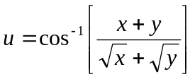 then find the value of 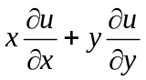 7
b) Using the method of laplace transform, solve the initial value problem 8
3. a) Define Laplace transform. State and prove first shifting theorem of laplace transform of 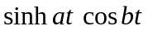 8
b) If the sum of the dimension of a rectangular swimming pool is given. Prove that the amount of water in the pool is maximum when it is a cube. 7
4. a) Solve(x+y)² y' =a² 7
b) Solve 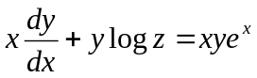 8
5. a) Find f(t) if 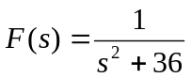 2*5
b) Verify the Euler's theorem for f(x,y)=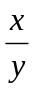
c) Write down the criteria of maxima and minima of three independent variables.
d) Solve 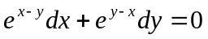
d) Solve 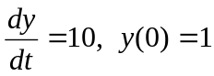
Nepal College of Information Technology
Unit Test
Spring 2011
Program : BE CE Time : 2 hrs
Semester : Fall (II) FM : 70
Subject : Engineering Math-II PM : 35

- Candidates are requested to give their answer as far as practicable in their own words.
- The figure in the margin indicates the full marks
- Attempt ALL question

1. a) State and prove Euler's theorem for a homogeneous function of degree n in x and y, verify it for f(x,y) = x³ + y³ 8
b) Find the minimum value of x²+y²+z² when x+y+z=3a² 7
2. a) If then find the value of 7
b) Using the method of laplace transform, solve the initial value problem 8
3. a) Define Laplace transform. State and prove first shifting theorem of laplace transform of 8
b) If the sum of the dimension of a rectangular swimming pool is given. Prove that the amount of water in the pool is maximum when it is a cube. 7
4. a) Solve(x+y)² y' =a² 7
b) Solve 8
5. a) Find f(t) if 2*5
b) Verify the Euler's theorem for f(x,y)=
c) Write down the criteria of maxima and minima of three independent variables.
d) Solve
d) Solve

